- Lab Title: Encryption, SSL/TLS, Secure Communications and Server Hardening
- Assignment Title: Final Project on Web Application Security Essential Building and Securing a Complete Web Application Environment
- Student Name: Bashir Adam
- Student ID: 2025/FWSD/11509
- Course Name: BVWS102 – Web Application Security Essentials
- Instructor Name: Ahmad Bukar
- Date of Submission: 3 NOV, 2025
- Version: Version 9.0

LAB OVERVIEW/OBJECTIVE
Overview: This final assignment evaluates your understanding of encryption, HTTPS, secure communication protocols, and server hardening techniques. You are required to demonstrate how these security measures protect data, prevent attacks, and improve the overall security posture of a web application.

SECTION1: Encryption Overvie
Encryption: is the process of converting readable information into an unreadable format so that only people with the correct key can turn it back into the original message

The Difference between Symmetric Encryption, Asymmetric Encryption, and Hashing
Symmetric Encryption | Asymmetric Encryption | Hashing
Same key is used to lock and unlock data. | Uses two different keys: a public key to encrypt and a private key to decrypt. | Converts data into a fixed-length code called a hash. It cannot be reversed back into the original data.
.
Why each is Important for Protecting Web Applications

- Symmetric Encryption: Protects sensitive data stored in servers and databases
- Asymmetric Encryption: Enables secure connections over the internet used in HTTPS/SSL so data sent between browsers and websites is protected.
- Hashing: Safely stores passwords. If attackers steal the database, they can’t see original passwords they only see hashes

Provide one real world example for each

1. Symmetric Encryption
Example: Encrypting files on your phone (Android or iPhone)
Your smartphone uses symmetric encryption to protect your files, photos, messages, and app data.
It uses one secret key inside the device to lock and unlock all your stored information.
- If someone steals your phone, they cannot read your data without your PIN/fingerprint (which unlocks the key).
- The same key is used to encrypt and decrypt the files, so it is fast.

2. Asymmetric Encryption
Example: HTTPS on websites (like when you open Gmail or Facebook)
When you see a padlock in your browser, the website is using asymmetric encryption.
- The website shares its public key with your browser.
- Your browser uses that public key to send a secret message.
- Only the server’s private key can decrypt it.
It protects your login details, online banking, and messages from being stolen while traveling across the internet.

3. Hashing
Example: Password storage in websites
When you create an account on Instagram, Facebook, or any website:
- The website does NOT store your real password.
- It stores a hashed version of your password.
When you log in:
- The password you enter is hashed again.
- If the hash matches the one in the database, you are allowed in.
Even if hackers steal the database, they only get the hash values, not the real passwords.

SECTION2: SSL/TLS and HTTPS
1. How SSL/TLS Works When a User Visits a Website
When you open a website that starts with https://, your browser uses SSL/TLS to create a secure, encrypted connection with the website’s server.
This prevents attackers from reading, stealing, or changing your data.

The handshake is the first part of the connection where the browser and server agree on how to communicate securely.
Step-by-step:
- Browser says hello:
  - The browser sends a message to the server asking to start a secure connection.
  - It also sends the list of encryption methods it supports.
- Server replies with its certificate:
  - The server sends back its SSL certificate (contains its public key).
  - The browser checks if the certificate is valid and trusted.
- Browser creates a secret key:
  - The browser creates a one-time session key (used for fast symmetric encryption).
  - It encrypts this session key using the server’s public key (asymmetric encryption).
  - Only the server’s private key can decrypt it.
- Secure communication begins:
  - Now both sides share the same session key.
  - The rest of the communication uses fast symmetric encryption.

The Purpose of Certificates
An SSL certificate is issued by a trusted Certificate Authority (CA) and serves two main purposes:
1. Identity verification
It proves that the website really belongs to the organization it claims to.
The certificate ensures that the site is truly icdfa.com and not a fake phishing site.

2. Provides the server’s public key
The certificate contains the public key used during the handshake.
This allows the browser to send encrypted messages that only the real server can read.
Without certificates, attackers could easily pretend to be legitimate websites.

Why Browsers Show the Lock Icon
The lock icon appears because:
- The website has a valid SSL/TLS certificate.
  - The certificate is not expired.
  - It was issued by a trusted CA.
  - It matches the website’s domain name.
- The browser successfully completed the SSL/TLS handshake.
  - Communication is fully encrypted.
  - No one can read or modify the data.

I simulate my HTTPS connection using Note.Js I wrote the first command “openssl req -newkey rsa:2048 -nodes -keyout server.key -x509 -days 365 -out server.crt” and then set the common name as “local host” Automatically two file were created which were “server.key and server.crt” And I open my notepad they write the following command
const https = require("https");
const fs = require("fs");

const options = {
key: fs.readFileSync("server.key"),
cert: fs.readFileSync("server.crt"),
};

https.createServer(options, (req, res) => {
res.writeHead(200);
res.end("HTTPS is working! Secure Connection Established.");
}).listen(443, () => {
console.log("HTTPS server running on https://localhost");
});

I then run the command “node https-server.js”on terminal

I’m glad I visited the side “https://localhost” on my browser

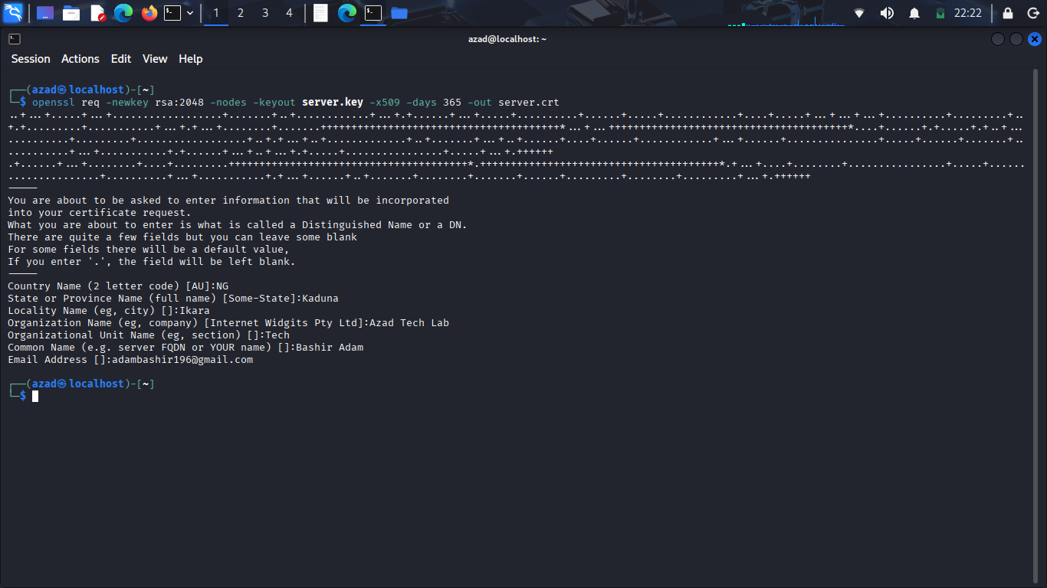

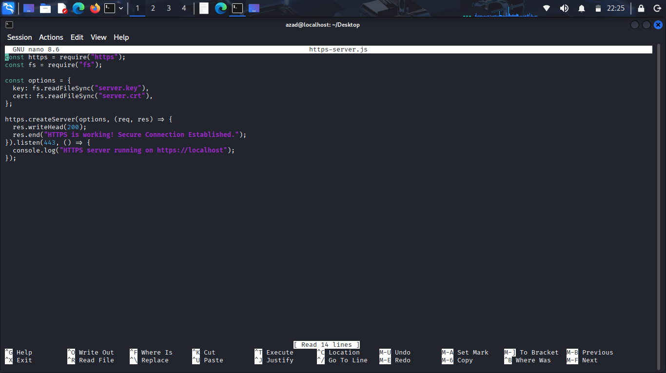

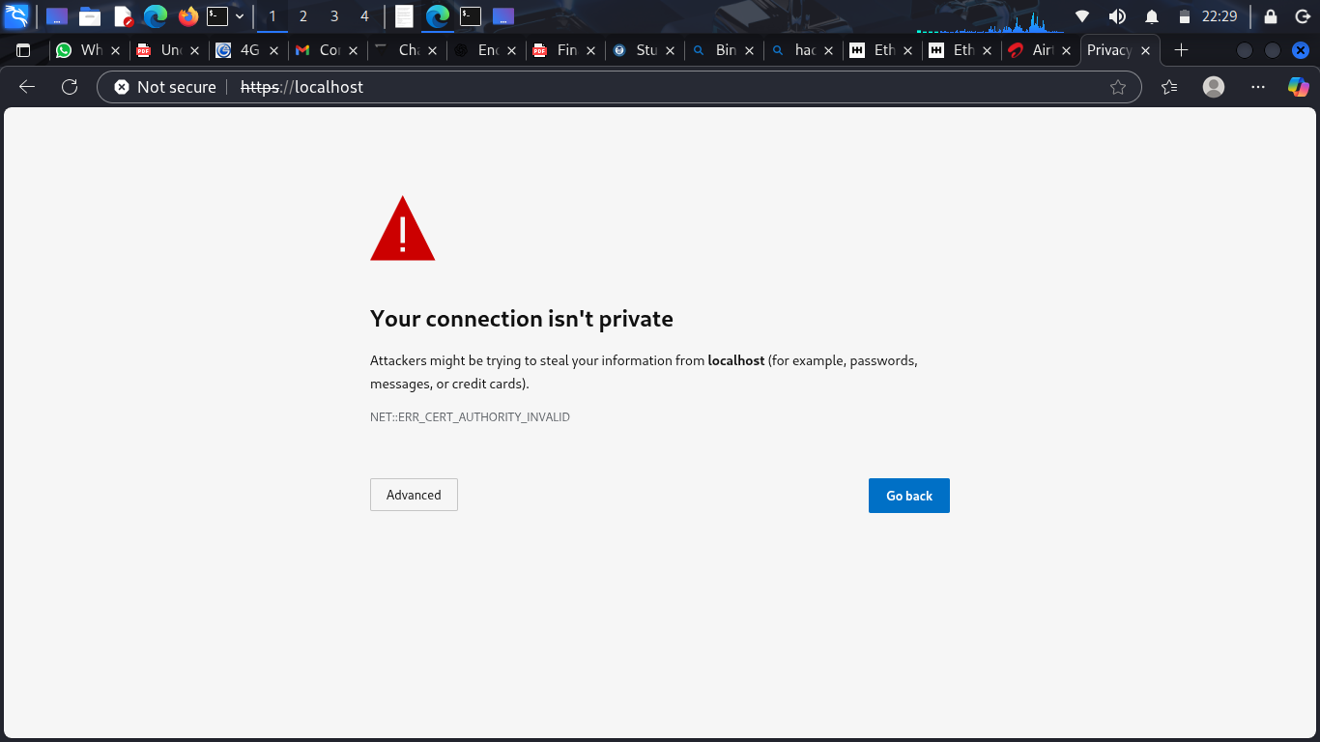

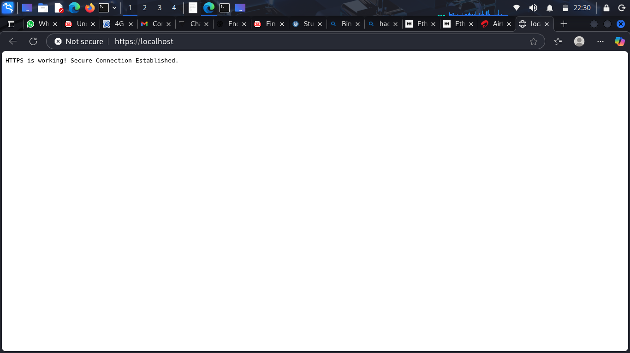

This is the screenshot of the HTTPS lock icon and the screenshots of certificate details

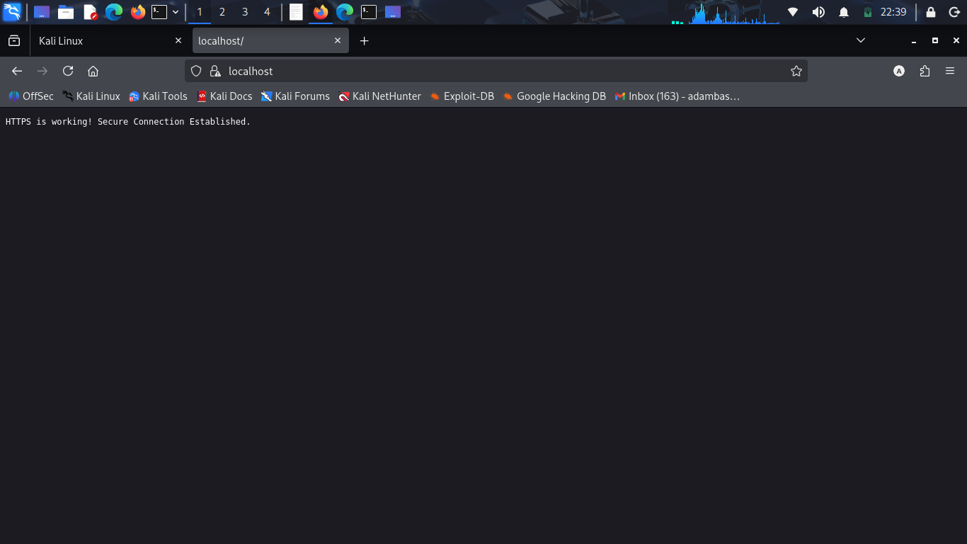

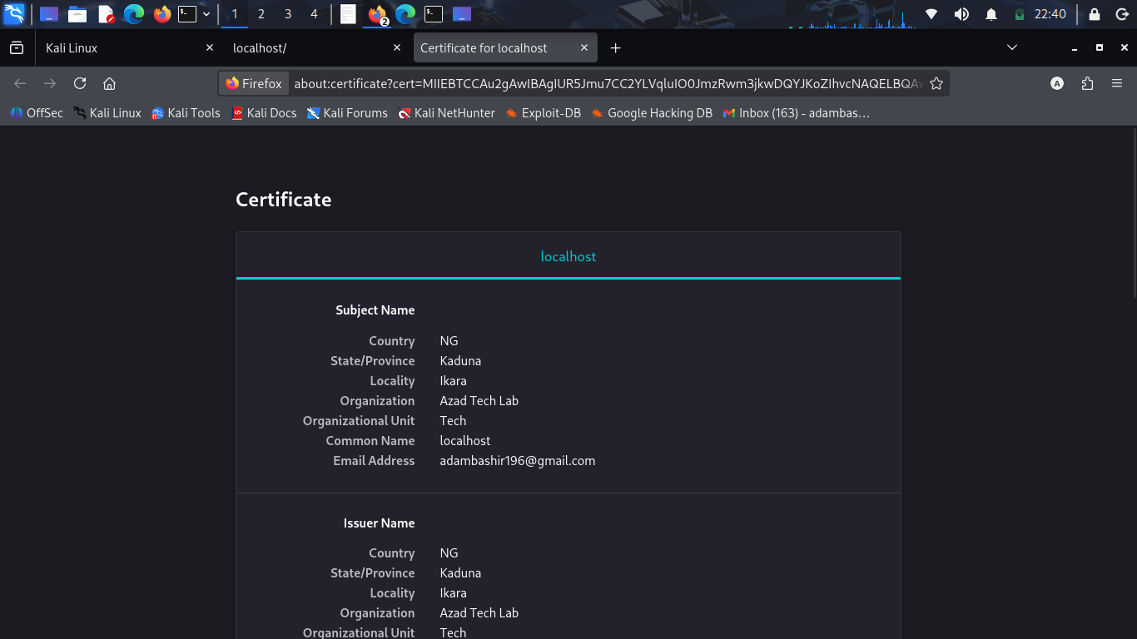

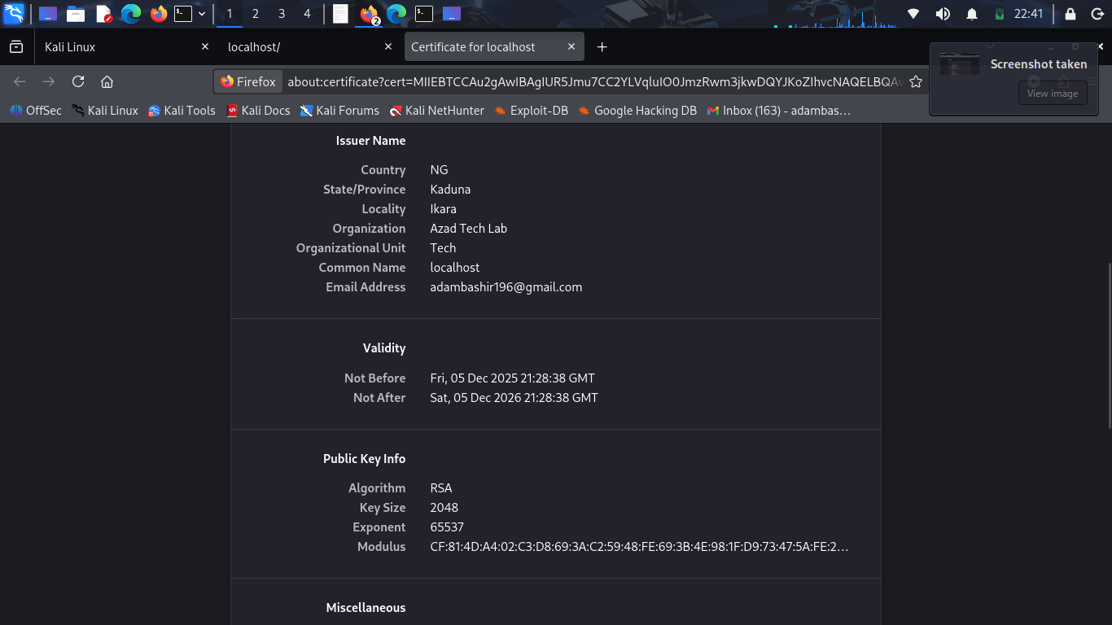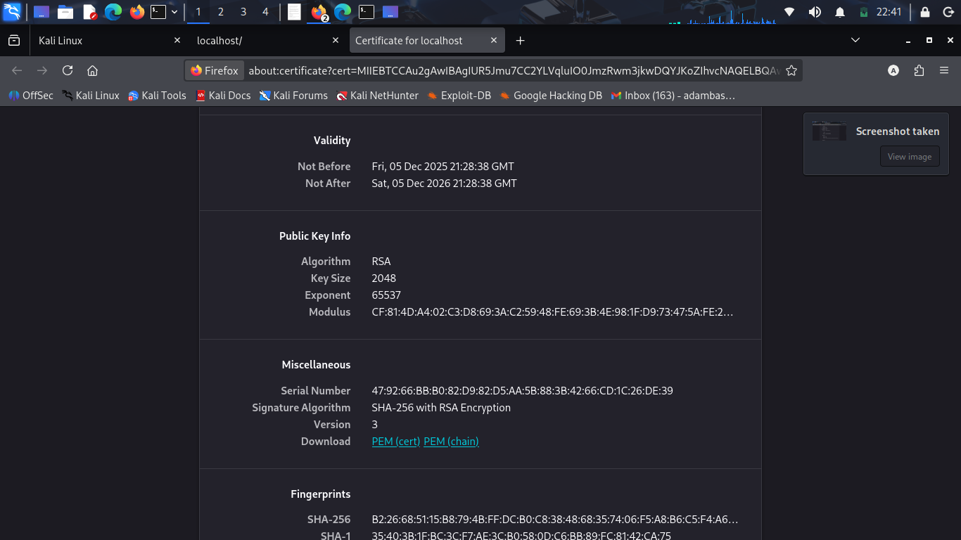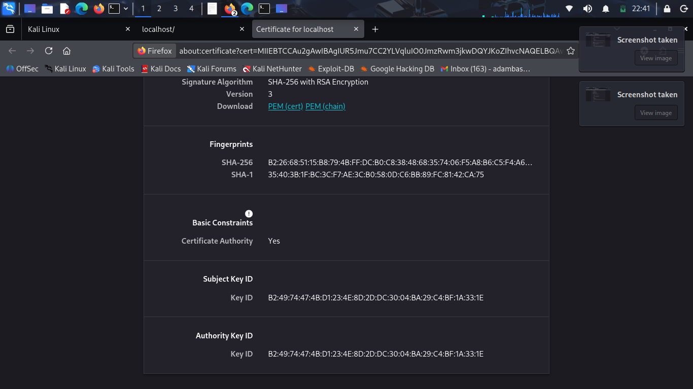

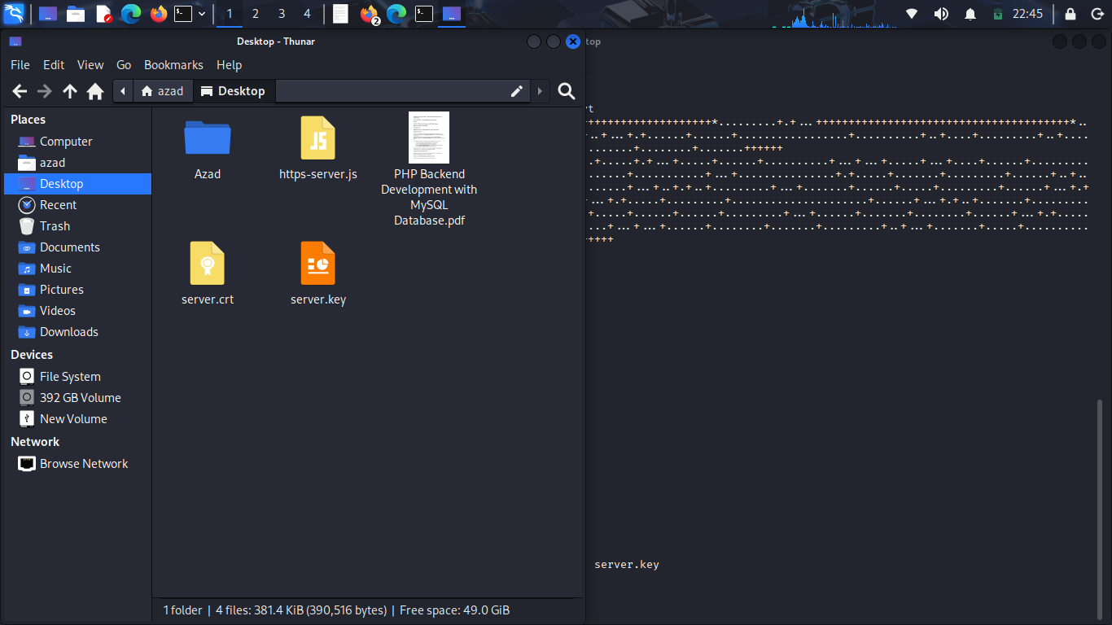

What Happens If a Website Uses HTTP Instead of HTTPS
When a website uses HTTP, the connection between your browser and the website is not encrypted.
This causes major security risks:
1. Data Is Sent in Plain Text (No Encryption)
Any information you type such as:
- usernames
- passwords
- emails
- credit card numbers
- personal details
can be seen by attackers on the same network (e.g., public Wi-Fi).
This is called packet sniffing.
2. Attackers Can Steal Login Credentials
Since the data is unprotected, an attacker can capture your:
- username
- password
- session cookie
This allows them to log in as you.
3. Attackers Can Modify the Website (MITM Attacks)
Without HTTPS, a hacker can perform a Man-in-the-Middle attack and:
- inject fake forms
- redirect you to a fake website
- add malware/ads
- change what the page displays
You will not notice anything suspicious.

SECTION4:SecureApplicationDevelop ment

<?php
/********************************************
* SECURE PHP LOGIN SYSTEM (ONE FILE)
********************************************/

// === DATABASE CONNECTION (EDIT IF NEEDED) ===
mysqli_report(MYSQLI_REPORT_OFF); // Hide internal MySQL errors
$conn = new mysqli("localhost", "root", "", "securedb");

// If connection fails, do not expose details
if ($conn->connect_error) {
error_log("DB Error: " . $conn->connect_error);
die("System Error. Please try later.");
}

// === CREATE TABLE IF NOT EXISTS ===
$conn->query("
CREATE TABLE IF NOT EXISTS users (
id INT AUTO_INCREMENT PRIMARY KEY,
username VARCHAR(50) UNIQUE,
password VARCHAR(255)
)
");

// === REGISTER DEMO USER IF NOT EXISTS ===
$demo_username = "admin";
$demo_password = password_hash("Admin123!", PASSWORD_BCRYPT);

$conn->query("INSERT IGNORE INTO users (username, password) VALUES ('$demo_username', '$demo_password')");

// === FUNCTION: CLEAN USER INPUT ===
function clean_input($data) {
return htmlspecialchars(strip_tags(trim($data)), ENT_QUOTES, 'UTF-8');
}

// === HANDLE LOGIN REQUEST ===
$message = "";

if ($_SERVER['REQUEST_METHOD'] === 'POST') {

$username = clean_input($_POST['username']);
$password = clean_input($_POST['password']);

// Prevent invalid usernames
if (!preg_match("/^[A-Za-z0-9_]{3,20}$/", $username)) {
$message = "Invalid username format.";
} else {

// Secure prepared statement
$stmt = $conn->prepare("SELECT id, username, password FROM users WHERE username = ?");
$stmt->bind_param("s", $username);
$stmt->execute();

$result = $stmt->get_result();

if ($result->num_rows === 1) {
$row = $result->fetch_assoc();

if (password_verify($password, $row['password'])) {
$message = "<span style='color:green;'>Login Successful!</span>";
} else {
$message = "Incorrect username or password.";
}
} else {
$message = "Incorrect username or password.";
}
}
}
?>

<!DOCTYPE html>
<html lang="en">
<head>
<meta charset="UTF-8">
<title>Secure Login System</title>

<style>
body {
font-family: Arial, sans-serif;
background: #e8f5e9;
}

.container {
width: 360px;
margin: 80px auto;
padding: 25px;
background: white;
border-radius: 10px;
box-shadow: 0 0 12px rgba(0,0,0,0.1);
}

h2 {
text-align: center;
color: green;
}

input {
width: 100%;
padding: 12px;
margin: 8px 0;
border: 1px solid #bbb;
border-radius: 6px;
}

button {
width: 100%;
padding: 12px;
background: green;
border: none;
border-radius: 6px;
color: white;
font-size: 16px;
cursor: pointer;
}

button:hover {
background: darkgreen;
}

.message {
margin-top: 15px;
text-align: center;
font-size: 14px;
color: red;
}

.info-box {
margin-top: 25px;
background: #f6fff6;
padding: 15px;
border-radius: 8px;
border-left: 4px solid green;
}

.info-box h3 {
margin-top: 0;
color: green;
}

code {
background: #f0f0f0;
padding: 3px 5px;
border-radius: 4px;
display: block;
margin-top: 5px;
}
</style>

</head>
<body>

<div class="container">
<h2>Secure Login</h2>

<!-- Login Form -->
<form method="POST">
<input type="text" name="username" placeholder="Username" required>

<input type="password" name="password" placeholder="Password" required>

<button type="submit">Login</button>
</form>

<!-- Status Message -->
<div class="message"><?php echo $message; ?></div>

<!-- Security Features Explanation -->
<div class="info-box">
<h3>Security Features Used</h3>

<b>✔ HTTPS:</b>
<code>Encrypts all communication to prevent sniffing.</code>

<b>✔ Password Hashing (bcrypt):</b>
<code>$hash = password_hash("Admin123!", PASSWORD_BCRYPT);</code>

<b>✔ Prepared Statements:</b>
<code>$stmt = $conn->prepare("SELECT * FROM users WHERE username = ?");</code>

<b>✔ Input Validation:</b>
<code>$username = clean_input($_POST['username']);</code>

<b>✔ XSS Protection:</b>
<code>htmlspecialchars(strip_tags());</code>

<b>✔ Secure Error Handling:</b>
<code>mysqli_report(MYSQLI_REPORT_OFF);</code>

<b>✔ SQL Injection Protection:</b>
<code>$stmt->bind_param("s", $username);</code>
</div>

</div>

</body>
</html>

